### 5

### CHILD PROTECTION PROMOTERS

### BASELINE SURVEY

### REPORT

### JULY 2024

# EXECUTIVE SUMMARY

This report presents the findings from a baseline survey conducted to assess child protection awareness, practices, and perceptions on the child protection promoters from Mararianda and Olkimitare villages. Key areas examined in the survey include demographic information, understanding and awareness of child protection laws, perceptions and reporting of child abuse, community reactions, and barriers to effective child protection. The survey reveals a general awareness of child protection measures among community members, but also highlights significant challenges such as lack of awareness, cultural beliefs, and lack of resources. Recommendations are provided to address these barriers and improve child protection efforts.

**Table Of Contents**

EXECUTIVE SUMMARY 1

INTRODUCTION 3

OBJECTIVES 3

METHODOLOGY 4

RESULTS 4

Demographic Information 5

Understanding and Awareness of Child Protection 5

Perception and Reporting of Child Abuse 6

Community Reaction to Child Abuse 7

Reporting Procedures and Experiences 7

Community Understanding of Child Protection 8

Barriers to Effective Child Protection 8

Suggested Improvements 9

RECOMMENDATIONS 9

Conclusion 9

**Table Of Figures**

Figure 1 :Prevalence of child abuse in the community 7

Figure 2 :Experience in reporting child abuse 8

# INTRODUCTION

**BACKGROUND**

Child protection is a critical issue that demands attention and action from all sectors of society. It encompasses measures and practices aimed at preventing and responding to violence, exploitation, and abuse against children. The well-being and safety of children are fundamental to the development of a healthy and prosperous community. However, achieving effective child protection often faces numerous challenges, including lack of awareness, cultural barriers, insufficient resources, and inadequate legal frameworks.

This report focuses on evaluating the current state of child protection within the community in Mararianda and Olkimitare Villages. Through a detailed survey, the study aims to gather insights on the community’s awareness of child protection laws, their perceptions and experiences regarding child abuse, and the effectiveness of existing reporting mechanisms. By analyzing these aspects, the report seeks to identify gaps and provide recommendations to enhance child protection measures.

## OBJECTIVES

The specific objectives of this report are:

1. **To assess the level of understanding and awareness of child protection laws among community members.**
2. **To evaluate the community’s perceptions of child abuse and their experiences with reporting such incidents.**
3. **To examine the community’s reactions to child abuse and identify both supportive and hindering factors.**
4. **To identify barriers to effective child protection and suggest actionable improvements.**

By addressing these objectives, the report aims to contribute to the ongoing efforts in safeguarding children’s rights and ensuring a safe and nurturing environment for their growth and development.

# METHODOLOGY

The survey was conducted among child protection promoters from Mararinda and Olkimitare to gather data on their awareness, understanding, and practices related to child protection. The methodology involved:

**Survey Design:** A structured questionnaire was developed, focusing on key aspects of child protection such as demographic information, awareness of child protection laws, experiences with reporting child abuse, and community reactions.

**Sampling:** The survey specifically targeted child protection promoters within Mararianda and Olkimitare villages. These individuals were selected for their roles and responsibilities in advocating for and safeguarding children's rights.

**Data Collection:** Data collection was carried out through questionnaires administered to the child protection promoters. Kobo Collect was utilized for this process due to its effectiveness in field surveys and its ability to function offline.

**Data Analysis:** The collected data were primarily qualitative, encompassing both open-ended and close-ended responses. The data analysis involved several steps:

* **Coding and Categorization:** Open-ended responses were coded and categorized to identify common themes and patterns. This process involved organizing the qualitative data into meaningful categories to facilitate interpretation.
* **Thematic Analysis:** Thematic analysis was conducted to identify key themes and insights from the qualitative data. This involved examining the coded data to uncover underlying themes related to awareness, reporting experiences, community reactions, and barriers to child protection.
* **Descriptive Statistics:** For close-ended responses, descriptive statistics were used to summarize and present the data in a clear and concise manner. This included calculating frequencies and percentages to highlight key findings.

**Ethical Considerations:** The survey adhered to strict ethical guidelines to ensure the confidentiality and voluntary participation of respondents. Informed consent was obtained from all participants, and measures were taken to protect their identities and the sensitivity of the information provided.

**Report Compilation:** The final step involved compiling the report. This included organizing the analyzed data into a coherent structure. The report was divided into sections such as the executive summary, introduction, methodology, results, discussion, and recommendations. Visual aids like charts, were used to enhance clarity and presentation.

# RESULTS

## Demographic Information

The survey respondents were distributed across different age groups. Among the respondents, 36.84% were aged between 18 to 35 years, 42.11% were between 35 to 50 years, and 21.05% were above 50 years old.

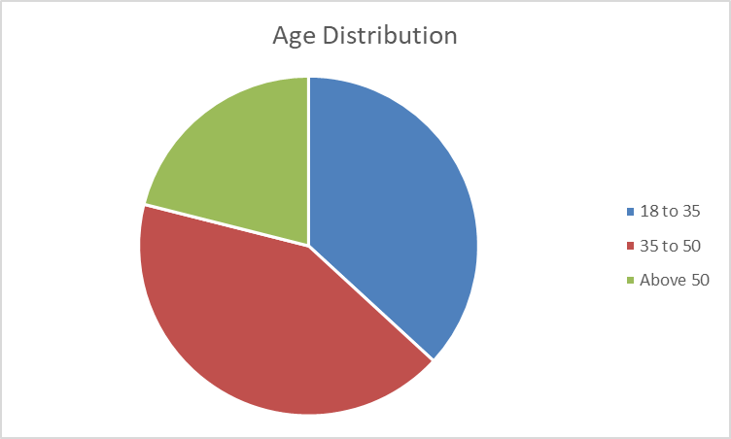

Regarding gender distribution, 47.37% of the respondents were female, while 52.63% were male.

The respondents' occupational status varied, with 10.53% being employed, 47.37% self-employed, 21.05% students, and 21.05% unemployed.

## Understanding and Awareness of Child Protection

Participants generally understand child protection as measures to safeguard children's rights and prevent abuse. They emphasized the importance of safeguarding children from harm and abuse, including measures to protect their rights and prevent abuse. Many mentioned promoting and fulfilling children's rights, ensuring that children can achieve their dreams without facing abuse. Educating children to distinguish between good and bad behavior was also noted as crucial. Additionally, protecting children from early marriages and pregnancies was a recurring concern.

Most respondents (78.95%) are aware of child protection laws or policies such as Protection from harmful practices like FGM, Prevention of early marriages,Prevention of child labor, and Educating the children The respondents provided insights into various child protection laws and policies they are familiar with. A significant focus was on protecting children from Female Genital Mutilation (FGM) and early marriages, emphasizing the need to fight against these harmful practices. The right to education for all children was also highlighted as a crucial policy. In addition, there was mention of policies against child labor and the importance of ensuring that children receive all their rights. Educating children was another critical area, reflecting the need to empower them through knowledge. The implementation of children-specific acts and ensuring compulsory education were also noted as essential measures for child protection.

Nearly half of the respondents (47.37%) have attended training or workshops on child protection.The training sessions were conducted by various organizations, with The Maa Trust being the primary facilitator, responsible for 44.44% of the sessions. Other contributors, each accounting for 11.11% of the training sessions, included Basecamp & The Maa Trust, Dandelion African Training, Friends of Conservation (FOC), The Church, and a collaboration between The Maa Trust & Karen Blixen. This distribution demonstrates a collaborative effort, with The Maa Trust taking a leading role and significant support from other organizations to ensure comprehensive training coverage.The topics covered in these trainings included Gender-Based Violence (GBV), Child Rights and Protection, and Early Pregnancies.

## Perception and Reporting of Child Abuse

Child abuse is recognized as any action that violates a child's rights, including physical, emotional, sexual abuse, and neglect. Forms of child abuse noted include Female Genital Mutilation (FGM), early marriages, early pregnancy, child labor, insults, dropping out of school, no provision to basic needs and exploitation.

The respondents provided a comprehensive understanding of child abuse, defining it as any action that neglects or violates a child's rights. They identified several forms of child abuse prevalent in their community, including early marriages and early pregnancy was highlighted as another form of exploitation. Child labor was cited as a violation of children's rights. The harmful practice of Female Genital Mutilation (FGM) was also mentioned, along with the severe violation of rights through rape and sexual exploitation of children. General neglect or abuse that violates a child's basic rights, such as education and basic needs, was also noted as well as overworking children within the community These responses reflect a deep awareness of the various forms of child abuse, emphasizing the need for protection against exploitation, neglect, and violation of children's fundamental rights.

When asked about the prevalence of child abuse in their community, 36.84% believe it is common, 36.84% believe it is rare, 15.79% believe it is very common, and 10.53% believe it is very rare. while a significant number of people acknowledge the presence of child abuse (with a combined 52.63% believing it is common or very common), there is also a substantial portion of the population (47.37%) that views it as rare or very rare, highlighting varying awareness levels regarding child abuse within the community. It is shown on Figure 1 below.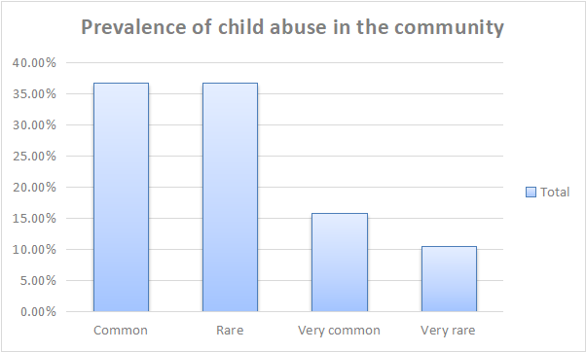

Figure 1:Prevalence of child abuse in the community

## Community Reaction to Child Abuse

The community's reaction to child abuse varies:

* **Positive Reactions**:
  + Reporting cases to authorities such as the chief, police, or child rights offices.
  + Creating awareness and educating the community about child abuse and protection.
  + Taking steps to stop child abuse, including evidence gathering and legal actions.
* **Negative or Indifferent Reactions**:
  + Ignorance and indifference towards child abuse.
  + Some community members do not take any action or consider child abuse unimportant.

## Reporting Procedures and Experiences

A majority of respondents (84.21%) indicated that there are clear procedures in place for reporting child abuse, which involve notifying local authorities like the village elder, chief, or police and also collecting evidence such as photos and videos where possible. Additionally, 83.33% know where to report cases of child abuse, with reports often directed to village elders, chiefs, police, or child offices.

Among those who have reported a case of child abuse (63.16%), the experience with the reporting process varied: 33.33% reported a satisfactory experience, 33.33% reported a very satisfactory experience, 25.00% had a neutral experience, and 8.33% reported an unsatisfactory experience as shown in Figure 2 below.

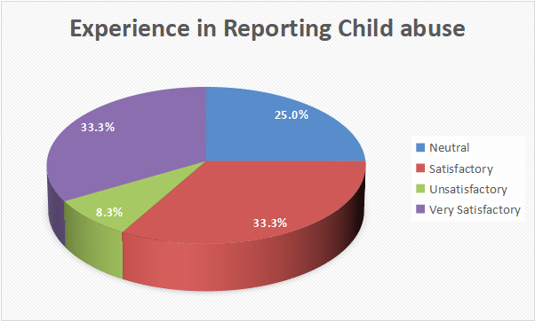

Figure 2:Experience in reporting child abuse

The majority of respondents who reported a case of child abuse cited timely actions and positive outcomes. Examples include children who were returned to school after being saved from early marriages and cases where boys who impregnated girls did not repeat the mistake after being reported. Other instances included the involvement of child offices as mediators and prompt responses to reports. Neutral responses indicated that while actions were taken and appreciation was shown, there were challenges, such as negative perceptions from the community and interference in reporting cases. A few expressed dissatisfaction with the lack of action taken by authorities.

## Community Understanding of Child Protection

When asked if they believe the community understands the importance of child protection, 36.84% strongly agreed, 31.58% agreed, 15.79% were neutral, 10.53% disagreed, and 5.26% strongly disagreed.

## Barriers to Effective Child Protection

The survey identified several barriers to effective child protection:

* Lack of awareness,
* Cultural beliefs,
* Insufficient resources,
* Inadequate legal framework.

## Suggested Improvements

Respondents suggested the following improvements to enhance child protection:

* Increasing awareness and education about child protection in communities.
* Encouraging the community to follow and enforce child rights.
* Providing more resources and support for child protection initiatives.
* Conducting more training and workshops on child protection.

# RECOMMENDATIONS

Based on the findings, the following recommendations are made to enhance child protection within the community:

**Increase Awareness and Education:** Implement comprehensive awareness campaigns to educate community members about child protection laws and the importance of safeguarding children's rights. Use various platforms such as community meetings, schools, and media to disseminate information.

**Strengthen Reporting Mechanisms:** Improve the accessibility and efficiency of reporting procedures by providing clear guidelines and support to community members. Establish dedicated child protection units within local authorities to handle cases promptly and effectively.

**Address Cultural Beliefs:** Conduct community dialogues to challenge harmful cultural practices and beliefs that hinder child protection. Engage community leaders and influencers to promote positive attitudes towards child rights and protection.

**Enhance Resources and Support:** Allocate more resources to child protection initiatives, including funding for training, workshops, and support services for victims

## Conclusion

This baseline survey reveals both progress and challenges in child protection within Mararianda and Olkimitare villages. Community members show commendable awareness of child protection laws and practices, understanding various forms of child abuse such as FGM, early marriages, and child labor. The significant role of The Maa Trust in conducting training sessions highlights the importance of community and external support.

However, the survey identifies key barriers to effective child protection, including lack of awareness, cultural beliefs, insufficient resources, and inadequate legal frameworks. Community reactions to child abuse vary from active reporting to indifference, indicating the need for ongoing education and advocacy.

Recommendations include increasing awareness and education on child protection, strengthening reporting mechanisms, addressing harmful cultural beliefs, and enhancing resources and support. Implementing these recommendations will help create a safer environment for children, ensuring their well-being and protecting their rights.